Experiment–7: Two Stage RC Coupled Amplifier

Group no: - 14 Date of Experiment: - 12/10/2023
Roll no: - 22CS02002 Name: - Soham Chakraborty

Pre-Lab Work: LTSpice simulation.
C

Circuit
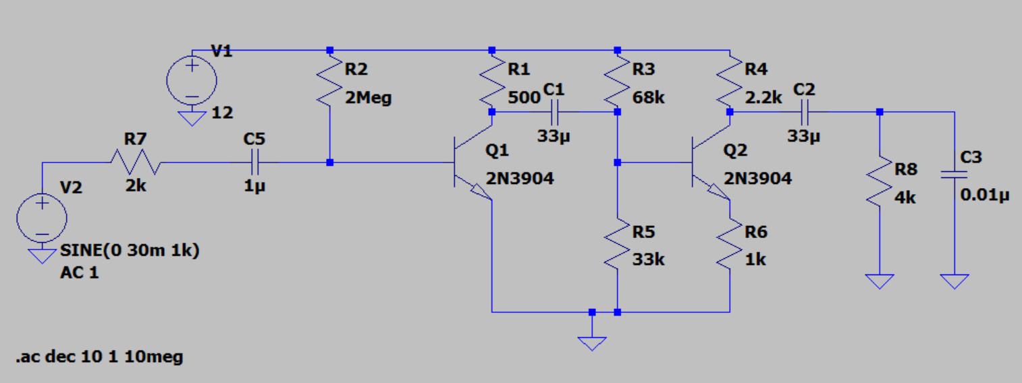

AC Analysis
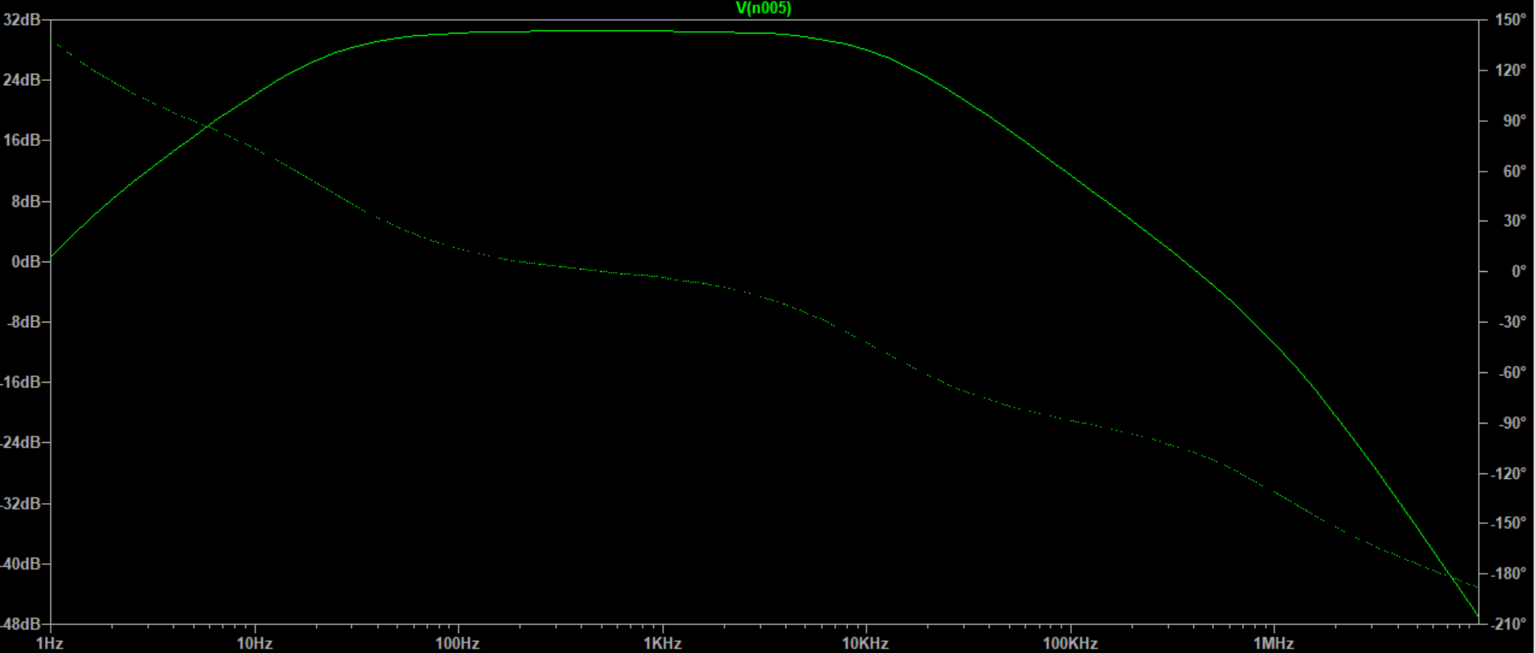
Operating Points
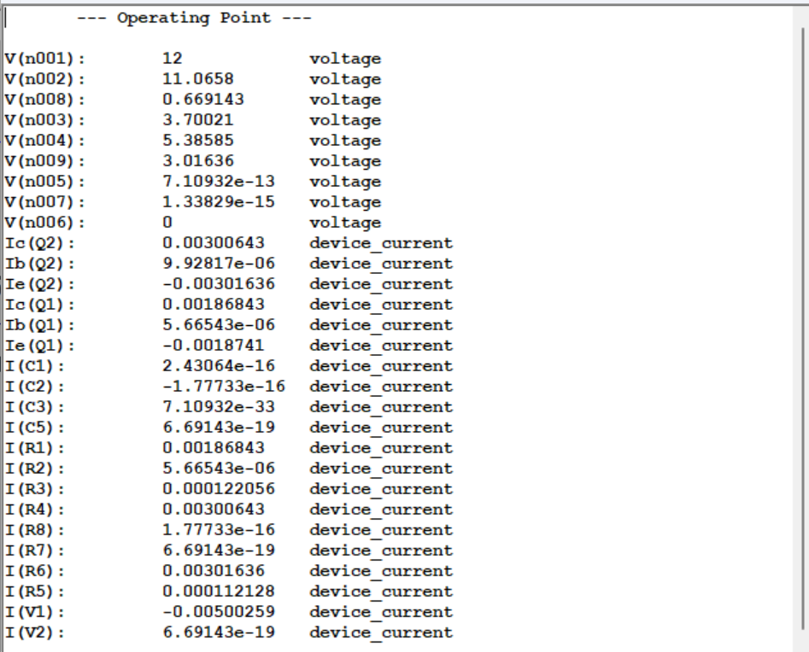
Two-stage RC Coupled Amplifier

Aim of the Experiment: - Build and observe the frequency response of the amplifier and
find the gains for both stages.

Equipment required: -
▶ Required resistor values– 2 MΩ, 68 kΩ, 33 kΩ, 2.2 kΩ, 500 Ω, 2 kΩ, 1 kΩ, 4 kΩ
▶ Breadboard (×1)
▶ Constant DC power supply 12V
▶ Function Generator
▶ DSO(Digital Storage Oscilloscope)
▶ 2N3904 transistor.
▶ Capacitor- 33uF(*2), 1uF, 0.01uF.
▶ Connecting wires

Circuit Diagram: -

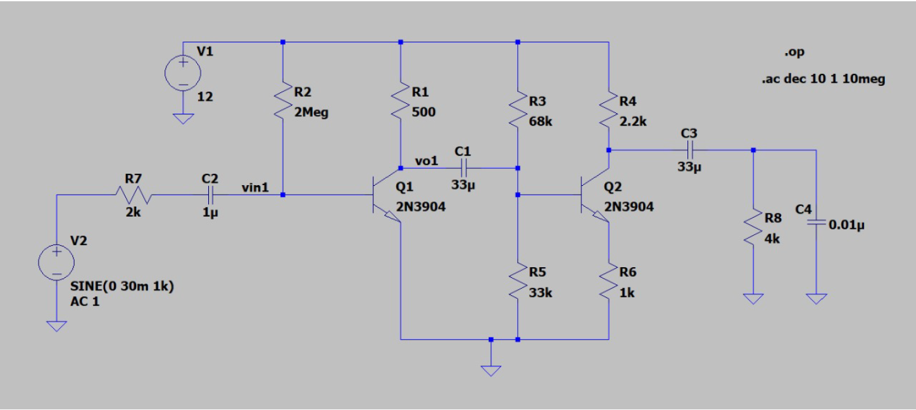

Observation Table:-

Frequency (in Hz) | V_{in}  (in mVpp) | V_{out} (in Vpp) | Gain | Gain (in dB)
10 | 30 | 0.310 | 10.36 | 20.31
13 | 30 | 0.401 | 13.38 | 22.53
15 | 30 | 0.424 | 14.15 | 23.02
20 | 30 | 0.541 | 18.05 | 25.13
25 | 30 | 0.620 | 20.67 | 26.31
40 | 30 | 0.635 | 21.18 | 26.52
50 | 30 | 0.661 | 22.05 | 26.87
75 | 30 | 0.666 | 22.20 | 26.93
100 | 30 | 0.674 | 22.49 | 27.04
250 | 30 | 0.696 | 23.20 | 27.31
500 | 30 | 0.715 | 23.85 | 27.55
750 | 30 | 0.739 | 24.66 | 27.84
1k | 30 | 0.743 | 24.77 | 27.88
2.5k | 30 | 0.729 | 24.32 | 27.72
5k | 30 | 0.708 | 23.60 | 27.46
7.5k | 30 | 0.680 | 22.69 | 27.12
10k | 30 | 0.546 | 18.21 | 25.21
25k | 30 | 0.381 | 12.72 | 22.09
50k | 30 | 0.271 | 9.05 | 19.14
75k | 30 | 0.177 | 5.91 | 15.44
100k | 30 | 0.121 | 4.05 | 12.17
250k | 30 | 0.062 | 2.09 | 6.43
500k | 30 | 0.034 | 1.15 | 1.25
750k | 30 | 0.022 | 0.76 | -2.34
1M | 30 | 0.013 | 0.46 | -6.67

Graphs:-

Plot of Gain(dB) vs Frequency on a semi-log graph

Calculations:-
- Theoretical:-
Considering the first part of the amplifier
Part-I:
I_{B} = $\frac{VDD-Vbe}{Rb}$ = 5.65 µA
r_{π} = $\frac{VT}{Ib}$ = 4.6 kΩ
A_{V1} = - $\frac{βRc}{rπ}$ = -28.804
R_{in1} = R_{B} || r_{π} = 4.6 kΩ
R_{out1} = R_{C} = 500 Ω
Part-II:
R_{TH} = $\frac{Rb1×Rb2}{Rb1+Rb2}$ = 22.217 kΩ
V_{TH} = $\frac{VDD ×Rb2}{Rb1+Rb2}$ = 3.92 V
I_{B} = $\frac{Vth-Vbe}{Rth+\left(1+β\right)Re}$ = 11.18 µA
r_{π} = $\frac{Vt}{Ib}$ = 2.33 kΩ
A_{V2} = $\frac{-βRc}{rπ+\left(1+β\right)Re}$ = -2.173
R_{in2} = R_{th} || (r_{π} + (1+β)R_{E} ) = 20.518 kΩ
R_{out2} = R_{c} = 2.2 kΩ
Equivalent Overall Gain

A_{V} = A_{V1} × A_{V2} × $\frac{Rl}{Rl+Rout2} × \frac{Rin2}{Rin2+Rout1}×\frac{Rin1}{Rin1+Rs}$ = 27.53

Gain(dB) = 20log(A_{V}) = 28.78
Cut-off frequencies:-
- f_{L1} = $\frac{1}{2π\left(Rin1+Rs\right)Cc1}$ = 24.16 Hz
- f_{L2} = $\frac{1}{2π\left(Rl+Rout2\right)Cc2}$ = 0.78 Hz
- f_{L3} = $\frac{1}{2π\left(Rout1+Rin2\right)Cc3}$ = 0.23 Hz
- f_{H} = $\frac{1}{2π(Rl|\left|Rout2\right)Cl}$ = 11.23kHz

- f_{L} = max(f_{L1}, f_{L2}, f_{L3}) = 24.16 Hz
- f_{H} = 11.23 kHz
Bandwidth = f_{H} – f_{L} = 11.20 kHz

- Observations:-
Mid-Band Gain = $\frac{Vout}{Vin}$ = 24.77
Gain (in dB) = 27.88 dB
Lower cut-off frequency f_{L} = 16Hz
Upper cut-off frequency f_{H} = 14 kHz
Bandwidth = f_{H} – f_{L} = 13.12 kHz

- LTSpice Values:-
Mid-Band Gain = $\frac{Vout}{Vin}$ = 33.53
Gain (in dB) = 30.51 dB
Lower cut-off frequency f_{L} = 24.5Hz
Upper cut-off frequency f_{H} = 11.1 kHz
Bandwidth = f_{H} – f_{L} = 10.09 kHz
Conclusion:-
- We Observed the functioning of a 2-stage RC Coupled Amplifier and it was observed that LTSpice simulated values, theoretical values/calculations and observed values are in close agreement with each other.
- There are deviations in the Simulated value partly because of the fact that in the lab BC547 was used whereas in the manual and simulation 2N3904 was used.
- The Mid-band Gain, Upper and lower cut-off frequency, was calculated numerically and from the experimental data as well as from the simulation in LTSpice.
- It was observed that the LTSpice simulation and the experimentally calculated values, match in their basic characteristics but have some differences in the numerical values, this might be due to various errors. But in this case, this is most likely due to errors in receiving signal by the DSO, which might have caused errors in values due to lack of precision at low frequency and amplitude.

Discussion:-

- What is 3dB cut-off frequency?

3dB cutoff frequency also known as the half-power frequency, is a point in frequency response of various electronic and electrical systems. It represents the frequency at which the signal’s power or amplitude is reduced to half of its maximum value, indicating a signification drop in signal strength.
Half the power, represents $\frac{1}{√2}$ times gain. Using the equation for gain.
Gain(dB) = 20log($\frac{1}{√2}$) $≈$ 3dB.
Hence, from here we get the term 3dB.
The gain at this frequency is 3dB lower than max. gain.

- What does bandwidth mean?
Bandwidth can refer to the range of frequencies over which the electronic component, circuit, or device can operate effectively. It is often used to describe the operations limit of amplifiers, filters and other electronic filters.
Mathematical formula for bandwidth for filters is:
Bandwidth = f_{H} – f_{L}
This formula denotes the range over which the signal gives a non-zero output or in this case has a drop in Gain(dB) of more than 3dB from the max gain or a Power drop of more than half of max. Power.

